**Practical 3**

**Aim: Installation of Hadoop and java in windows.**

**🡪**

## Installation on java jdk and jre

### Step 1: Download SE Development Kit from the given link <https://www.oracle.com/in/java/technologies/javase/javase8-archive-downloads.html>

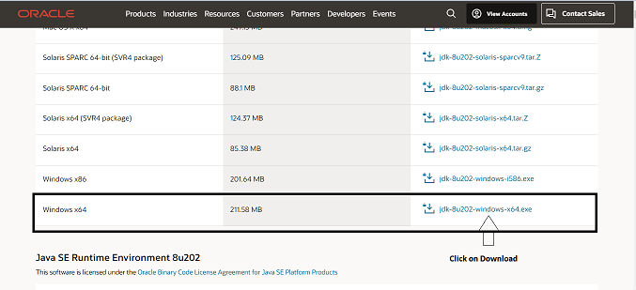

#### Step 2: Download Java SE Runtime Environment 8u202 from the given link <https://www.oracle.com/in/java/technologies/javase/javase8-archive-downloads.html>

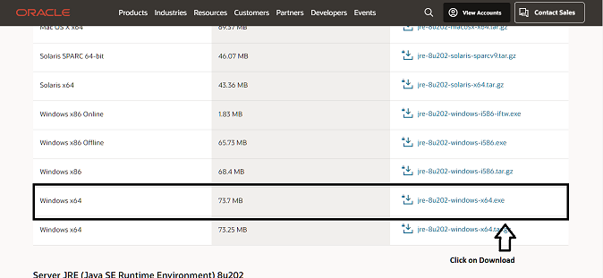

## Setting up the JDK in Environmental Variable

### Step 1: Start 🡪 Edit the system environment variables

### Step 2: Click on the environment Variables

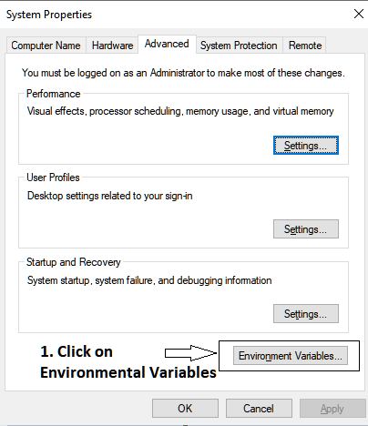

### Step 3: Create the new user variables

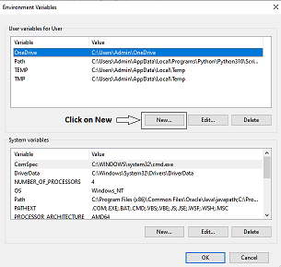

### Step 4: Give the Variable Name and java jdk path (NOTE: Rename the path C:\Program files\Java\jdk1.8.0_202 to C:\Progra~1\Java\jdk1.8.0_202)

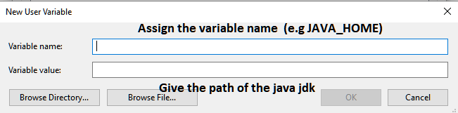

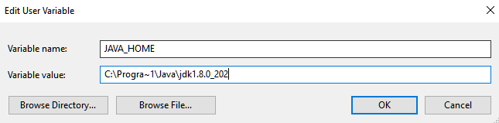

### Step 5: Add the Variable into the Path

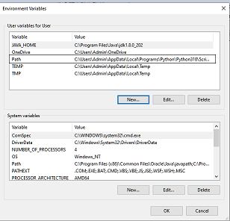

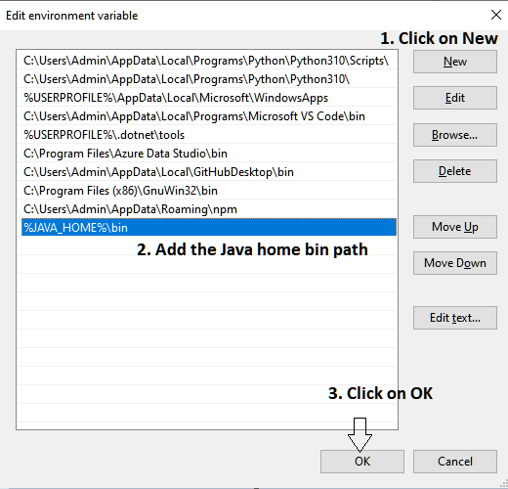

### Step 6: Create the new system variables

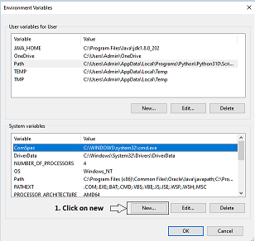

### Step 7: Give the Variable Name and java jdk path (NOTE: Rename the path C:\Program files\Java\jdk1.8.0_202 to C:\Progra~1\Java\jdk1.8.0_202)

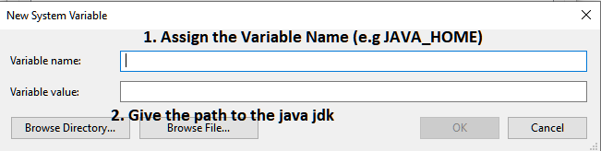

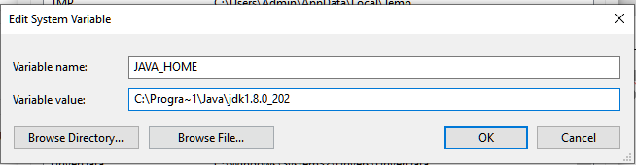

### Step 8: Add the Variable into the Path

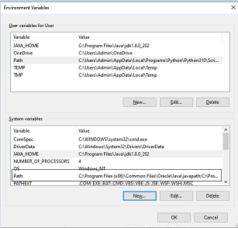



## Installation of Hadoop

### Step 1: Download Apache Hadoop from the given link and click on the binary <https://hadoop.apache.org/releases.html>

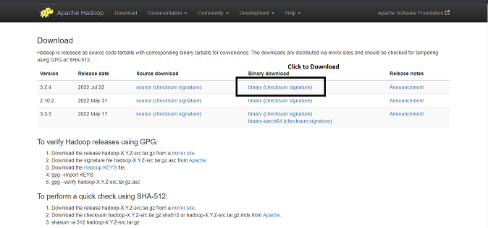

### Step 2: Click the link to download the zip

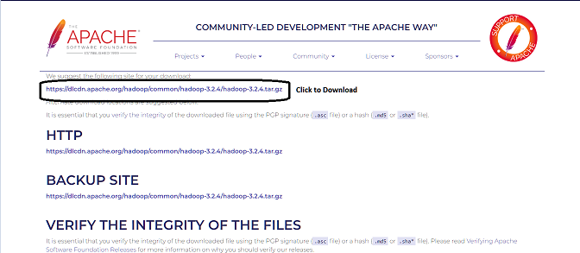

## Installation of the 7zip

### Step 1: Download the 7zip and install into the system <https://www.7-zip.org/download.html>

## Extracting Hadoop zip using 7Zip

### Step 1 : Right Click on the zip 🡪 Click on 7-zip 🡪 Extract Here

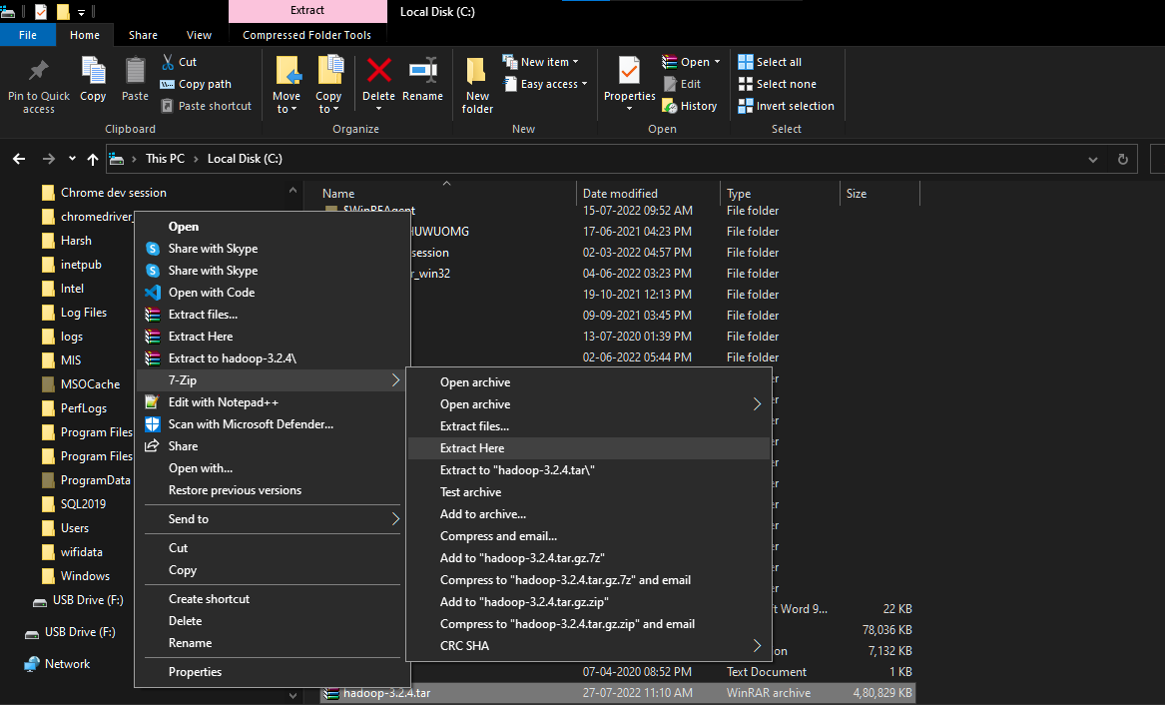

## Setting up the Hadoop in Environmental Variable

### Step 1: Start 🡪 Edit the system environment variables

### Step 2: Click on the environment Variables



### Step 3: Create the new user variables



### Step 4: Give the Variable Name and java Hadoop path

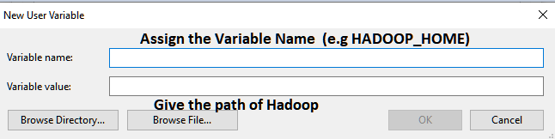

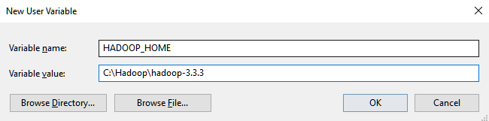

### Step 5: Add the Variable into the Path



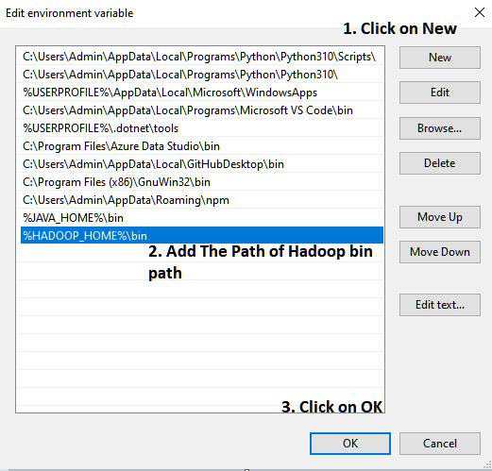

### Step 6: Create the new system variables



### Step 7: Give the Variable Name and java Hadoop path

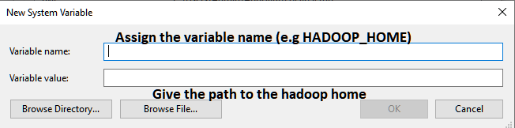

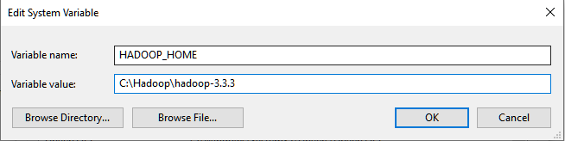

### Step 8: Add the Variable into the Path





## Setting up Hadoop

### Step 1: Create the new Folder with the name DATA

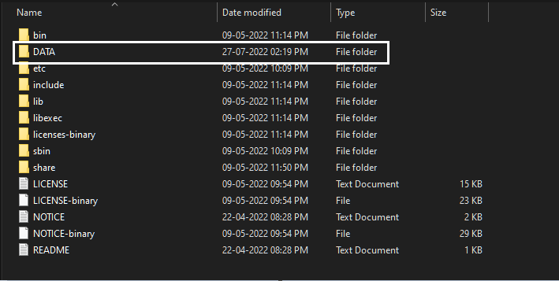

### Step 2: Go inside the data folder and create 2 folder i.e. NameNode and DataNode

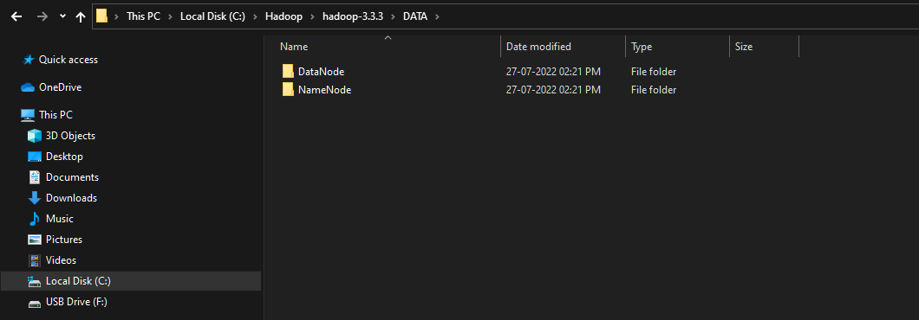

### Step 3: open the file **hdfs-site.xml** C:\Hadoop\hadoop-3.3.3\etc\hadoop

<?xml version="1.0" encoding="UTF-8"?>

<?xml-stylesheet type="text/xsl" href="configuration.xsl"?>

<configuration>

  <property>

    <name>dfs.replication</name>

    <value>3</value>

  </property>

  <property>

<name>dfs.namenode.name.dir</name>

<value>C:\Hadoop\hadoop-3.3.3\DATA\NameNode</value>

</property>

<property>

<name>dfs.datanode.data.dir</name>

<value>C:\Hadoop\hadoop-3.3.3\DATA\DataNode</value>

</property>

<property>

  <name>dfs.permissions</name>

  <value>false</value>

</property>

</configuration>

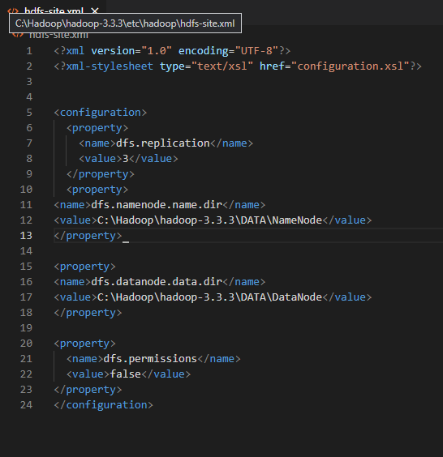

### Step 4: open the file **core-site.xml** C:\Hadoop\hadoop-3.3.3\etc\hadoop

<?xml version="1.0" encoding="UTF-8"?>

<?xml-stylesheet type="text/xsl" href="configuration.xsl"?>

<!--

  Licensed under the Apache License, Version 2.0 (the "License");

  you may not use this file except in compliance with the License.

  You may obtain a copy of the License at

    http://www.apache.org/licenses/LICENSE-2.0

  Unless required by applicable law or agreed to in writing, software

  distributed under the License is distributed on an "AS IS" BASIS,

  WITHOUT WARRANTIES OR CONDITIONS OF ANY KIND, either express or implied.

  See the License for the specific language governing permissions and

  limitations under the License. See accompanying LICENSE file.

-->

<!-- Put site-specific property overrides in this file. -->

<configuration>

<property>

<name>fs.default.name</name>

  <value>hdfs://localhost:9000</value>

<!-- <value>hdfs://localhost:9820</value> -->

</property>

</configuration>

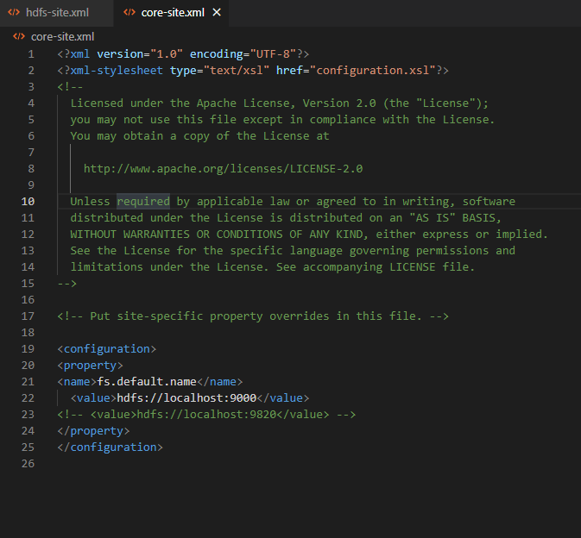

### Step 5: open the file **mapred-site.xml** C:\Hadoop\hadoop-3.3.3\etc\hadoop

<?xml version="1.0"?>

<?xml-stylesheet type="text/xsl" href="configuration.xsl"?>

<!--

  Licensed under the Apache License, Version 2.0 (the "License");

  you may not use this file except in compliance with the License.

  You may obtain a copy of the License at

    http://www.apache.org/licenses/LICENSE-2.0

  Unless required by applicable law or agreed to in writing, software

  distributed under the License is distributed on an "AS IS" BASIS,

  WITHOUT WARRANTIES OR CONDITIONS OF ANY KIND, either express or implied.

  See the License for the specific language governing permissions and

  limitations under the License. See accompanying LICENSE file.

-->

<!-- Put site-specific property overrides in this file. -->

<configuration>

<property>

<name>mapreduce.framework.name</name>

<value>yarn</value>

</property>

<property>

<name>mapreduce.cluster.local.dir</name>

<value>${hadoop.tmp.dir}/mapred/local</value>

</property>

</configuration>

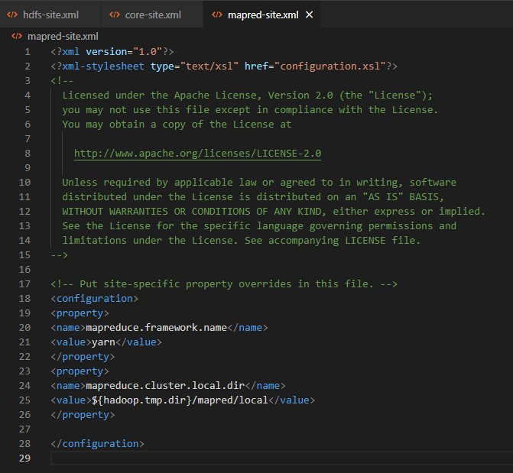

### Step 6: open the file **yarn-site -site.xml** C:\Hadoop\hadoop-3.3.3\etc\hadoop

<?xml version="1.0"?>

<!--

  Licensed under the Apache License, Version 2.0 (the "License");

  you may not use this file except in compliance with the License.

  You may obtain a copy of the License at

    http://www.apache.org/licenses/LICENSE-2.0

  Unless required by applicable law or agreed to in writing, software

  distributed under the License is distributed on an "AS IS" BASIS,

  WITHOUT WARRANTIES OR CONDITIONS OF ANY KIND, either express or implied.

  See the License for the specific language governing permissions and

  limitations under the License. See accompanying LICENSE file.

-->

<configuration>

<!-- Site specific YARN configuration properties -->

<configuration>

<property>

<name>yarn.nodemanager.aux-services</name>

<value>mapreduce_shuffle</value>

</property>

<property>

<name>yarn.nodemanager.auxservices.mapreduce.shuffle.class</name>

<value>org.apache.hadoop.mapred.ShuffleHandler</value>

</property>

</configuration>

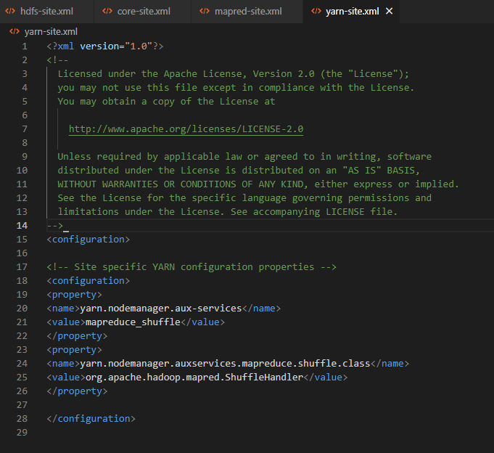

### Step 7: Go to GitHub <https://github.com/Selfgrowth/Apache-hadoop-3.1.1-winutils> and download the bin folder and replace all the files with the C:\Hadoop\hadoop-3.3.3\bin

### Step 8: Open the command prompt and change the location to C:\Hadoop\hadoop-3.3.3\bin

### Step 9: hdfs namenode -format

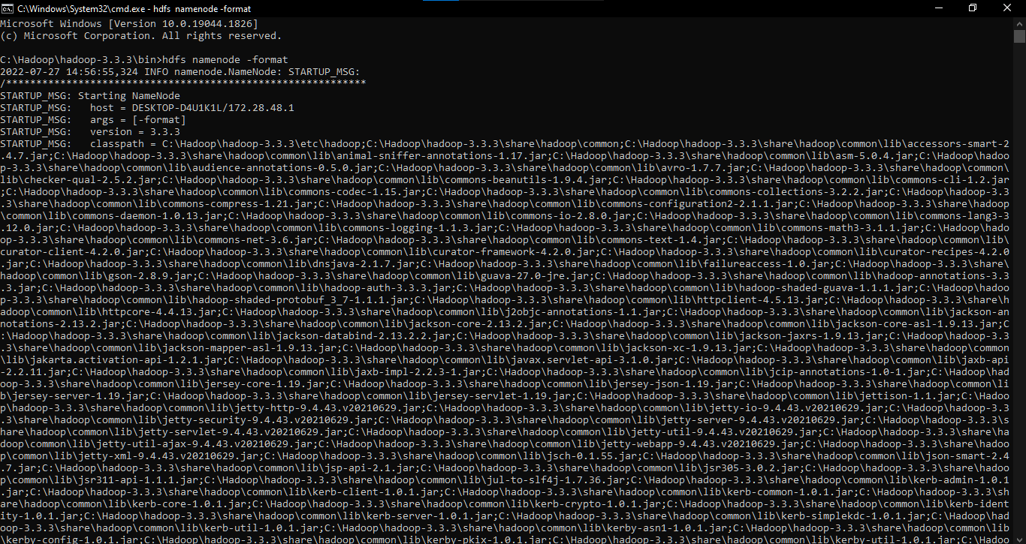

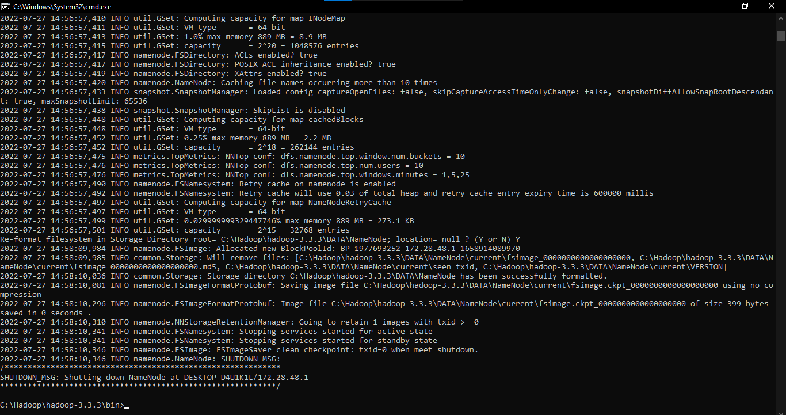

### Step 10: Go to sbin folder. Type cmd in the address bar and 2 different open command prompt

First cmd: **.\start-dfs.cmd**

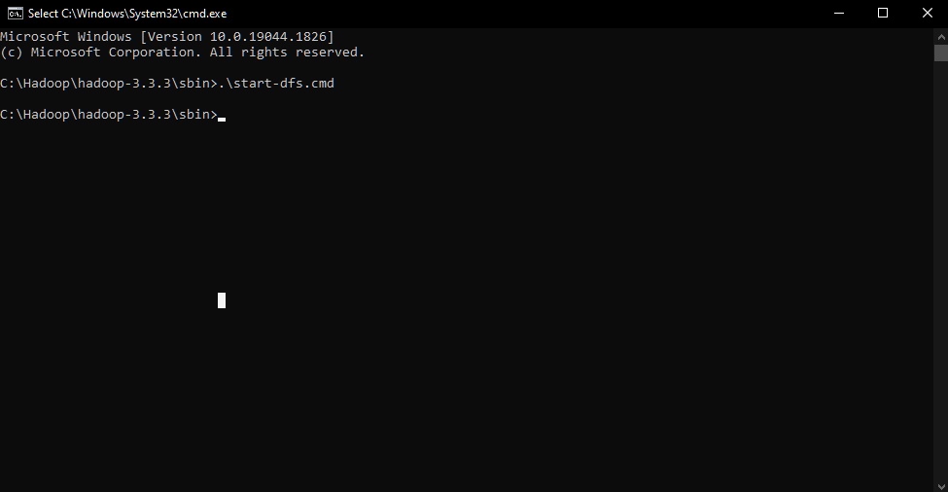

Second cmd: **.\start-yarn.cmd**

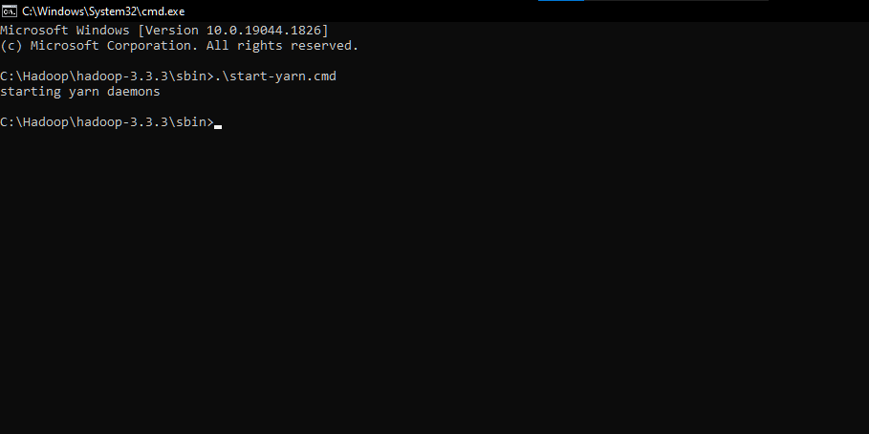

### Step 11: now open chrome or any other browser and type <http://localhost:9870/>

